# Assignment-3

## Github Link:<https://github.com/shaileshdarji1/Java-Application-3>

## Create a branch from the master and made some changes.

* First Create empty repository at both side(local and remote)
* Create Add.java file
* Commit this file in master branch
* Create new branch name branch1
* Switch to branch1
* Make some changes in Add.java File

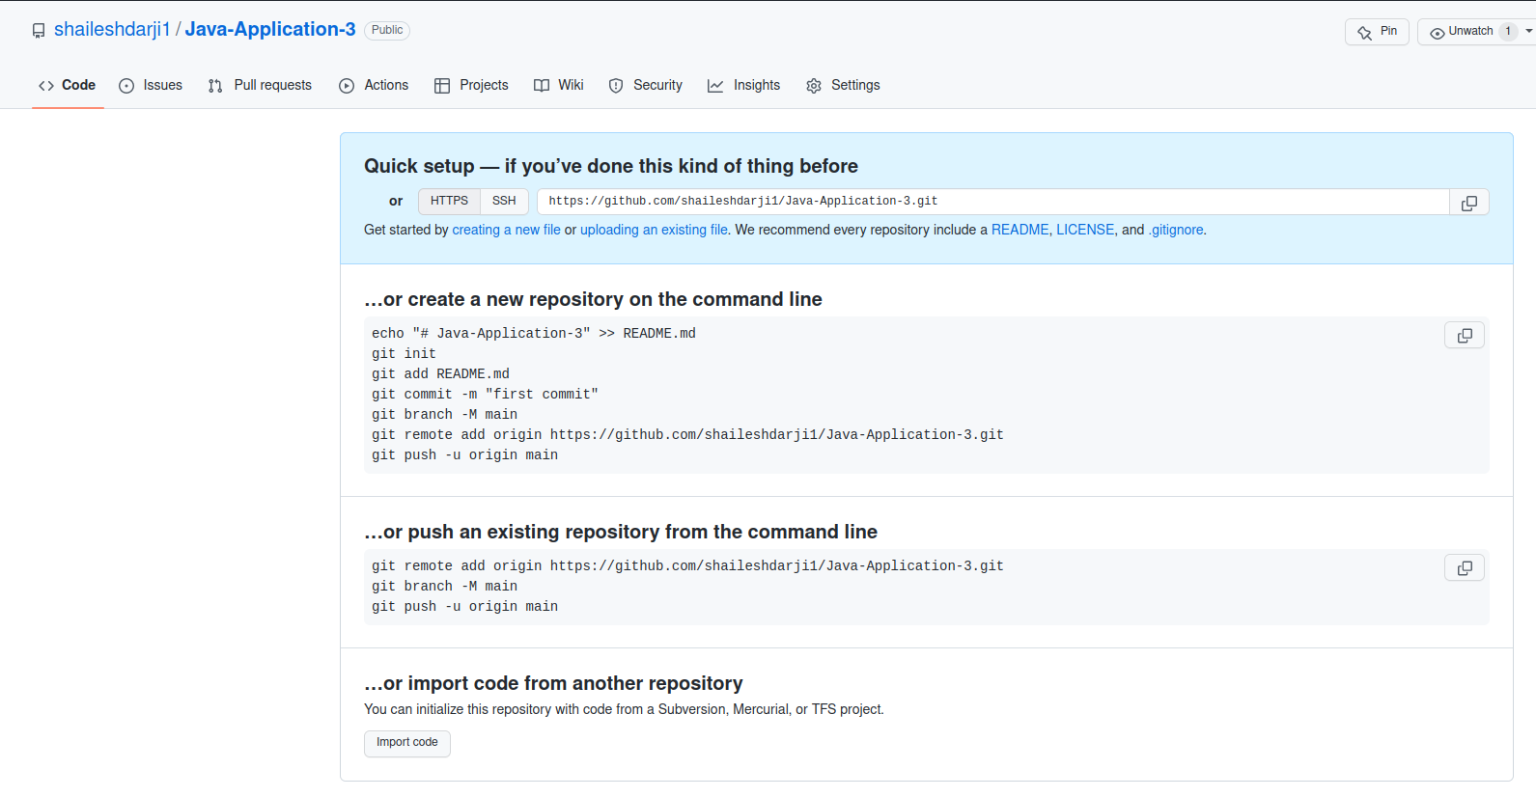

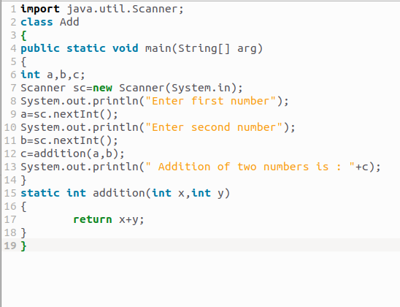

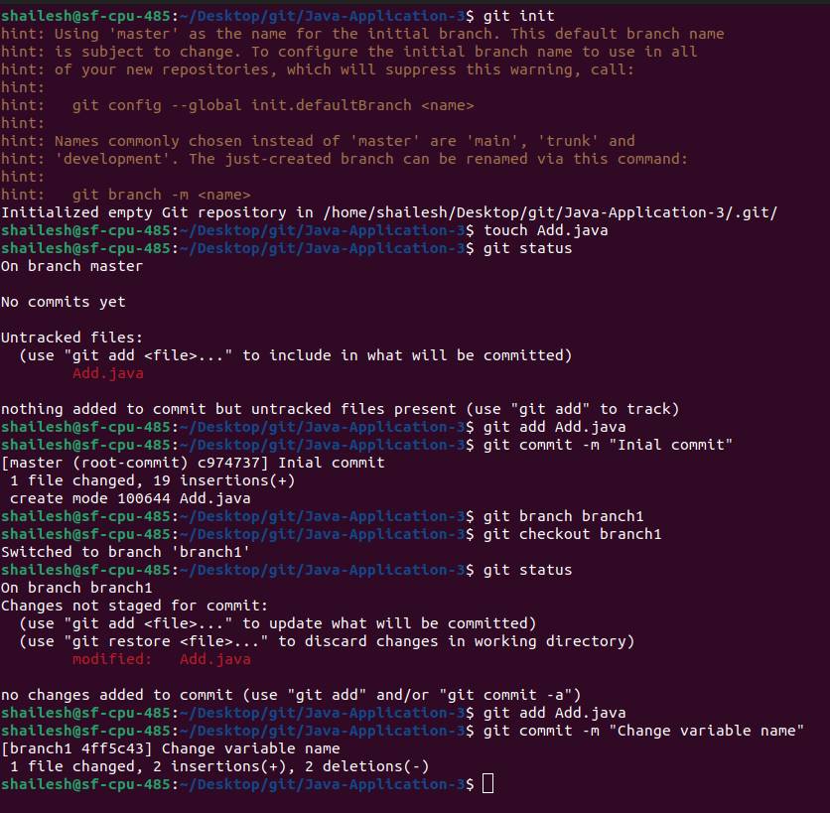

## Commit code in a branch.

* Put Add.java file into staging area
* After Staging area commit this file.
* Also push on github.so our changes visible to everyone.



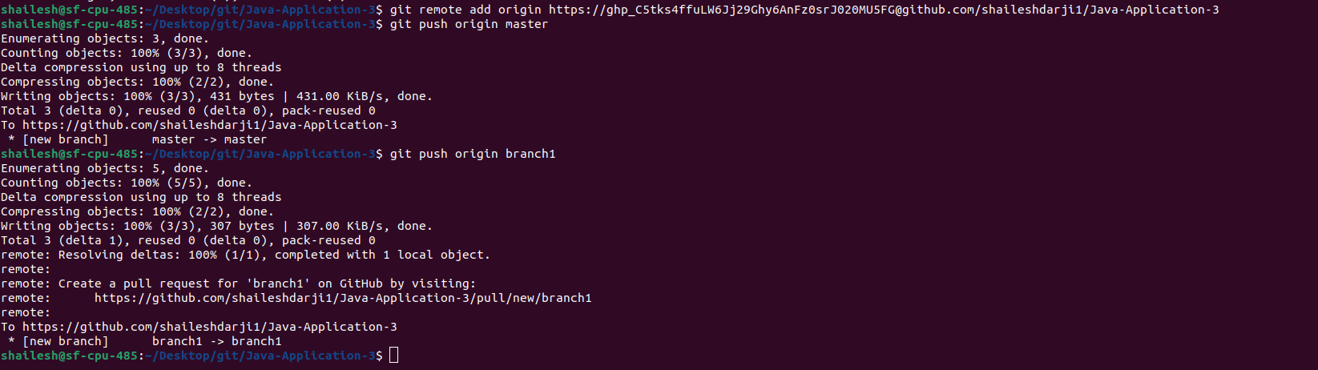

## Revert recently committed code.

* First use git log command to see our commit detalis.
* Here Copy last commit hash code.
* git revert <hash code(copied hash code paste here)>
* Also these changes push on github.
* See our revert details again use git log --oneline.

